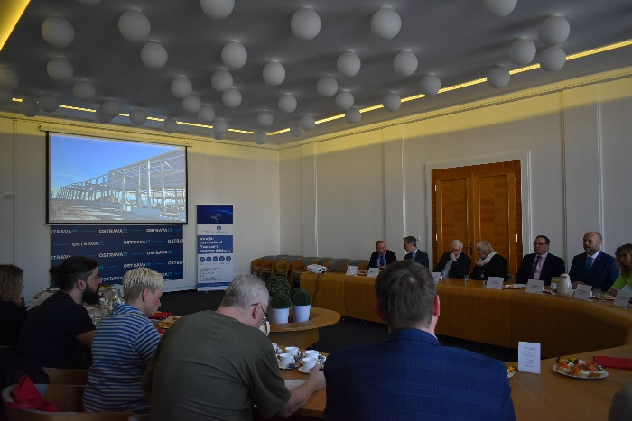
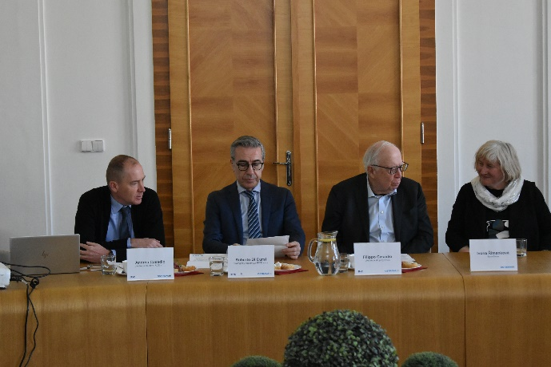
PRESS RELEASE

More jobs in the Mošnov industrial zone

The Ostrava City Council has approved the sale of land in the strategic industrial zone in Mošnov to the Italian company IRCE in 2021. Production facilities are being built on the land, where the company will produce copper and aluminium winding conductors. Construction work on the approximately 20,000 sqm factory began in the third quarter of last year and is expected to be completed by the end of 2024, after which production and product deliveries will begin. IRCE is one of the main players in Europe in the production of winding conductors for electrical machines, usually called enameled wires that consist of a copper and aluminium conductor upon which an insulation organic film is applied. They have multiple applications such as electric motors, generators, transformers, compressors, etc. By 2028, IRCE has a planned production of 10,000 tonnes per year and is ready to accommodate a production capacity of up to 36,000 tonnes per year by installing modular additions to individual lines. Recruitment has already begun and will include 60 to 90 employees in the first phase. As IRCE is a purely manufacturing company, its project will also create in the area of Ostrava significant satellite activities such as security, concierge, cleaning (building and packaging), maintenance of plants and systems, and gardening.

"The revitalisation of what was essentially a military brownfield and its transformation into an effectively functioning industrial zone in Mošnov brought nearly 4,700 jobs by the end of last year. I appreciate the fact that the City of Ostrava has managed to conclude contracts with the Italian investor IRCE, which offers very specific products for electromobility, which is the future of clean and therefore emission-free transport," said Jan Dohnal, Mayor of Ostrava.

IRCE was founded in Imola in 1947 and its shares have been listed on the stock exchange since 1996. As of 4/2021, IRCE shares are part of a high-grade market segment called "STAR." In 1998, the internationalization of the Group started (1998 NL, 2001 UK, 2007 BR-IN, 2010 DE) and now IRCE is starting its operations in the Czech Republic. The Italian investor IRCE differs from its competitors for several reasons as the production of the whole range of enamelled conductors, secondly, IRCE has historically internal know-how for the design of part of the machinery, moreover, has a solid financial structure and family transparent and trustworthy corporate governance that allows investments and continuous growth.

- "According to market analysts, demand in our market segment will grow exponentially over the next decade. The investment in the Czech Republic offers our Group the opportunity to make the best use of production capacity to respond quickly and efficiently to the growing market demand that the transition to electricity will generate. In addition, the investment in Mosnov has several strategic advantages, such as its location in the heart of Europe and close to important customers, excellent infrastructure and transport links," said Filippo Casadio, Chairman of IRCE Group. Roberto Di Cursi, IRCE's Strategic Supervisor, added: "The transparent and friendly relationship that has been established between our professionals and the city administration has allowed for an optimal management of the acquisition process and still allows for the smooth running of the last phase of the approval process. I would like to thank Massimiliano Pastore for his legal support and all the public administration staff, in particular, Václav Palička and Ladislav Bražina for their prompt response to all my requests, which contributed to the success of this project."

IRCE highlighted that only new-generation equipment produced by European suppliers will be installed in compliance with environmental sustainability. This will ensure that the production process is quiet and does not cause disturbance and disruption in the vicinity. R&D investments are planned, therefore, IRCE will need and hire many engineers to optimize and improve the production processes. For this reason, cooperation with the “VSB Technical University of Ostrava” will be possible too.

"IRCE's presence will expand the current supplier-customer base of companies in the automotive and electrical industries, among others. It will also have a positive impact on the labour market in the region. The Moravian-Silesian region is still dealing with the consequences of the decline in coal mining and the restructuring of the industry. We are the region with the second highest unemployment rate in the Czech Republic. Every new job created is important for us. We have been presenting the region to foreign investors for a long time and it is not easy to succeed in the competition of the nearby Polish market. The intensive work of our regional development agency – Moravian-Silesian Investments and Development in close cooperation with colleagues from the cities, together with the factors of the region's strategic location, human capital and in this particular case the transport facilities of Mošnov as a unique multimodal logistics hub, is bearing fruit," added Šárka Šimoňáková, Deputy Governor.

The strategic industrial zone Ostrava-Mošnov with an area of 200 hectares is part of an industrial complex with a total area of 292 hectares. The construction of technical infrastructure in this zone was supported by the subsidy programme for the support of business real estate and infrastructure under the auspices of the Ministry of Industry and Trade of the Czech Republic.

"A key element of modern global trade is air transport, which is the fastest and most efficient, especially for longer distances. I believe that the arrival of new investors to the Moravian-Silesian Region is also facilitated by the development of Ostrava Airport, which we strongly support. Thanks to the growing volume of cargo transported, we opened a new cargo terminal last autumn. We are strengthening our network of cargo flights. In addition to the existing three routes to Leipzig and Cologne in Germany and Tashkent in Uzbekistan, another scheduled route to Almaty in Kazakhstan was added this month. I therefore see the increase in cargo capacity and services at the airport as one of the key factors in attracting new investment to the region as a whole, but especially to the Strategic Industrial Zone of Mošnov, which is immediately adjacent to the airport. The attractiveness of this location is continuously increasing, even for companies planning to use other types of transport. For example, by rail," said Josef Bělica, the Governor of the Moravian-Silesian Region.

Mošnov is also composed of the area "R" to the southwest of the zone and the locality of the so-called small development zone with an area of approximately 38.5 hectares, on which the construction plan of "Panattoni Park Ostrava Airport" by the investor Panattoni is being prepared. These sites, together with the areas managed and prepared by the Moravian-Silesian Region, form the so-called extended area of interest Mošnov, which is being developed in coordination with both owners. The free capacity for the entry of new investors is 59.3 hectares, including the so-called "K" area to the southeast of the multimodal logistics centre and two areas adjacent to the land owned by Mobis and XZB. The first major investor in the strategic zone was Mahle Behr Ostrava, one of the largest employers with Plakor Czech. Other companies operating in the area include Cromodora Wheels, Ostrava Airport Multimodal Park, Mobis Automotive System Czech, XZB and IRCE.

"It is absolutely breathtaking to see the dynamic development of the industrial zone in Mošnov, in which the Statutory City of Ostrava has invested and built the infrastructure with the financial participation of the Ministry of Industry and Trade of the Czech Republic. The arrival and location of IRCE, as well as other investors, not only shows the importance and lucrativeness of the area, but also indicates how the city of Ostrava manages to implement and develop strategic projects. On behalf of the City of Ostrava, I can confirm that this is not the last investment. Already at the moment, on the basis of a memorandum of cooperation with the Moravian-Silesian Region, we are preparing a masterplan for the use of the pre-airport area. The land will be consolidated under the City of Ostrava, which will be the guarantor of the development of the area. We firmly believe that a decent centre of trade and services will gradually be built here, which will make the airport more attractive. We see it as an important gateway to Ostrava. At the same time, there will be additional spaces for the location of headquarters of companies and investors, such as IRCE," concluded Hana Tichánková, Deputy Mayor.

